RTL-SDR
A Software Designed Radio. Can listen to radio frequencies and has many resources for software that could accomplish things such as:
- Listen to airband
- Listen to radio
- Track aircraft (Show you graphically where the aircraft is moving and what aircraft it is.)
- Listen to Radio frequencies and record them (which can then be used to open a car etc..)

Common frequencies:
- Car Key fobs: 315 or 433 MHz
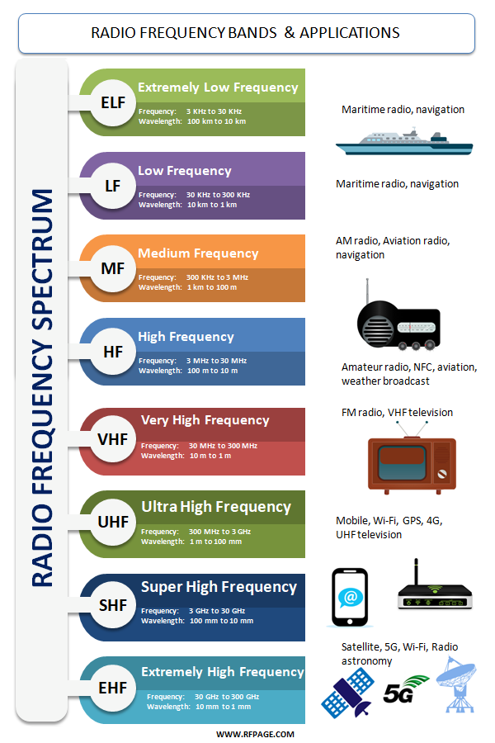
Software:

-Virtual Radio server
- Once installed, head to Tools > Options > Receiver
- Click on Wizard > A software defined radio
- Use Dump1090 as the decoder

-Raspberry Pi RTL-SDR tool (used for car key fob Replay Attack)
W.I.P.
-GQRX
A complete SDR environment. Can be used on a Raspberry Pi.
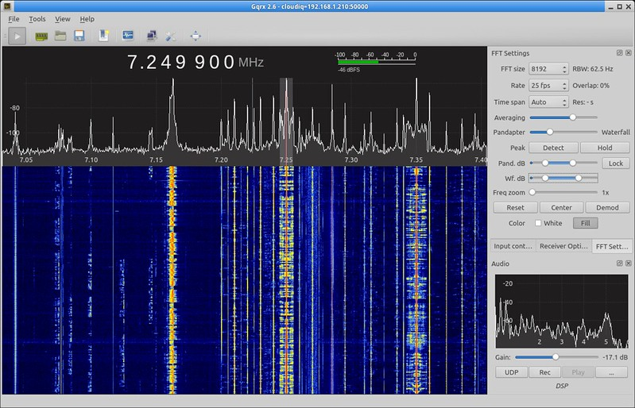
- Go to https://gqrx.dk/download/gqrx-sdr-for-the-raspberry-pi to download.
- Install the software installation package.
- Unzip the installation package.
- Drag and drop the package to the downloads folder.
- Run the software from there.

